Layover Lifesaver: the all-new ACCENTUM Plus
The upgrade you need for all-day adventures in sound

Chicago, Illinois, February 20th, 2024 – Sennheiser officially launches their ACCENTUM Plus headphones, bringing along premium fan-favorite features to the battery-sipping lineup.

“ACCENTUM Plus expands the reach of MOMENTUM 4’s most coveted conveniences, while upholding the spirit of the ACCENTUM family’s incredible value,” says Christian Ern, Sennheiser Principal Product Manager, “The Plus sits right in the sweet spot of blissful sound and convenient technology.”
Immersive, ‘round-the-clock listening
In a world with endless content consumption options, ACCENTUM Plus has the stamina and controls for you to enjoy all of it. Featuring Sennheiser's expansive acoustic expertise, touch-gesture controls, Hybrid Adaptive Noise Cancellation and a luxurious build, they prioritize a better headphone listening experience for less.
With a class-leading 50 hours of listening between charges and sound that rivals that of a stable, cabled connection, it’s easy to forget that ACCENTUM Plus is even wireless. The Bluetooth® 5.2 headphones emphasize outstanding sound quality and versatile connectivity, supporting all popular codecs including aptX™ Adaptive for optimum sound no matter where you decide to take them.
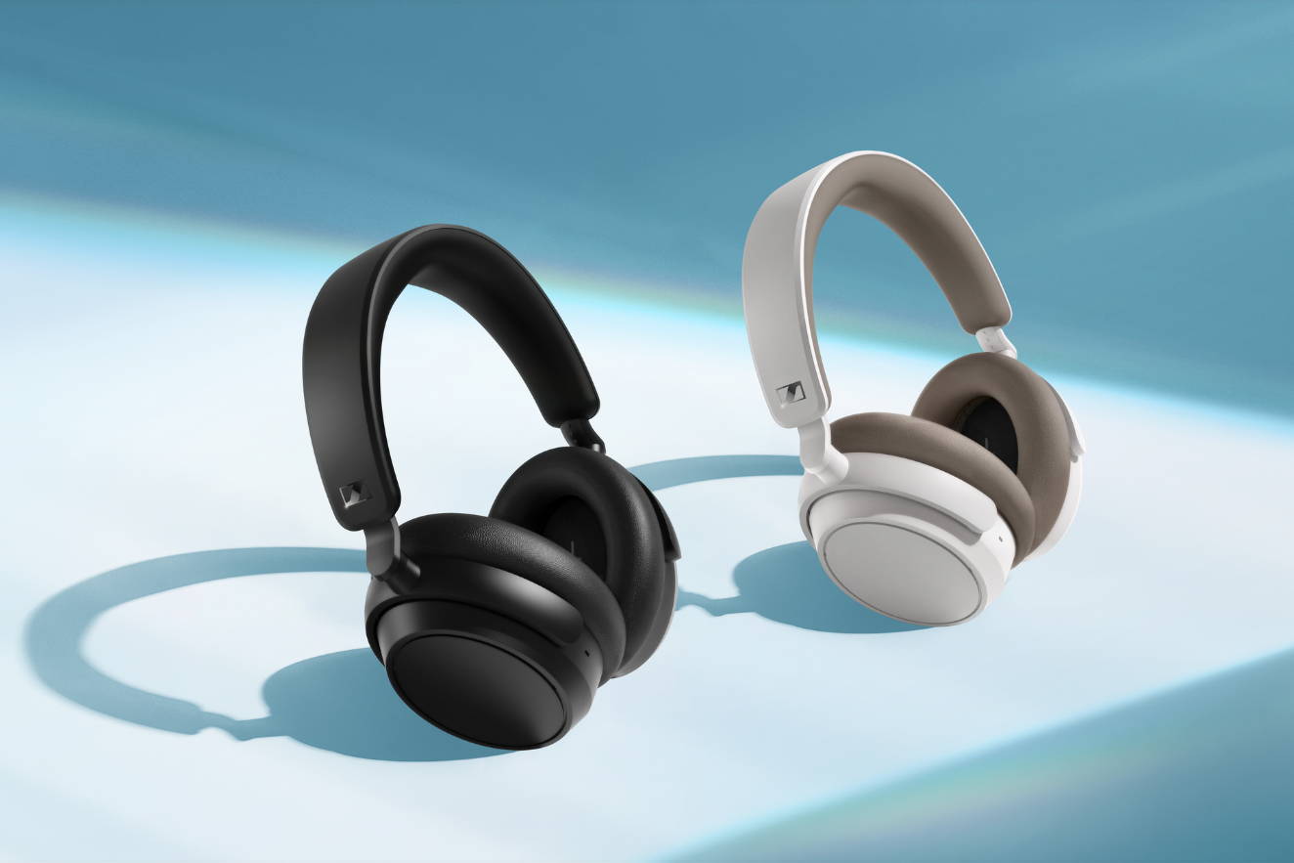
The proprietary 37mm dynamic transducer features Sennheiser’s Sound Personalization mode to match over 75 years of audio expertise to the listener’s sonic preferences—all without sacrificing the bass performance and striking detail the brand is known for. Powerful Adaptive ANC performance will delight commuters, optimizing its noise target to constantly adapt to changes in the ambient noise environment around the wearer. This dramatically reduces constant distractions so that the subtle details in your content shine through, naturally.
Quick charge—if you even need to
Not only does ACCENTUM Plus offer globe-trotting endurance, it also boasts a "quick charge" feature that adds an extra 5 hours of listening time in about 10 minutes. The provided USB-C cable also allows the listener to stream music from a class compliant audio device like a laptop while charging—the headphones convert into an audio interface for content consumption and even voice communication. The marathon battery life further extends the time between charges, taking far longer to reach the maximum number of charge cycles over the lifespan of the headphone battery, reducing electronic waste and aligning with Sennheiser’s commitment to sustainability.

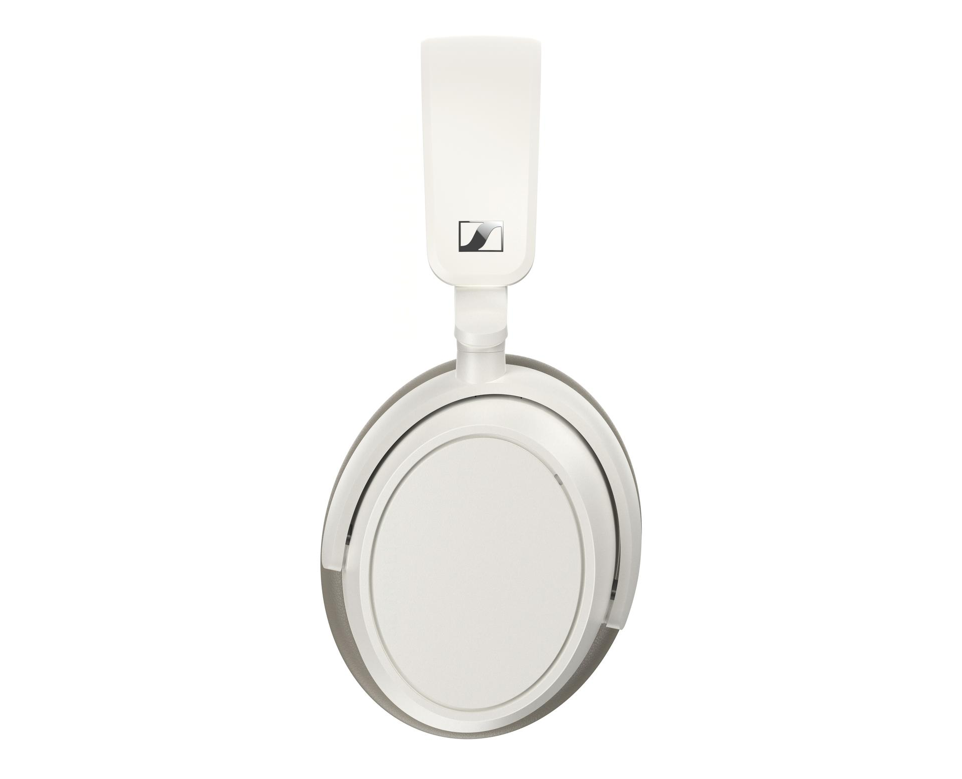
A Touch of control
ACCENTUM Plus can be controlled two main ways thanks to an intuitive touch panel and companion app that respond to gesture controls: familiar taps and swipes manage listening levels, wireless media controls, and transparency mode so you can get keep your hands on your device or put it away entirely. A touch-enabled earcup—also used in the flagship MOMENTUM series—offers immediate feature control without needing to search for buttons or dive into menus. For power users, automatic wind-reduction and adjustable side-tone keeps calls natural and free from distractions. Multipoint connectivity seamlessly switches the active wireless connection from one Bluetooth device to another without the need for re-pairing.

The Smart Control App elevates the headphone experience by effortlessly handling Bluetooth connections, exploring the 5-band EQ, and adjusting a plethora of audio-centric features. All of this is presented through a refreshingly simple visual user interface that fits neatly in your pocket. Smart Control also allows users to store personalized presets—perfect for when your smartphone platform or listening habits change.

On-the-go flow
ACCENTUM Plus’ playtime is only matched by its comfort. The earcup and headband padding adapt to the wearer's contours, providing reassuring stability through a gentle touch. And for those times when wireless listening is not permitted, an included audio cable with a 3.5mm stereo plug can be used to tap into in-flight entertainment systems or other headphone outputs. ACCENTUM Plus folds flat and ships with a protective zip-storage case to keep your new favorite travel headphones and accessories organized while on the move.

Pricing and availability
ACCENTUM Plus are available in black and white, beginning on February 20th, 2024. Both models will be available at select retailers and at sennheiser-hearing.com at an MSRP of $229.95 USD / $329.95 CAD.

About the Sennheiser brand
We live and breathe audio. We are driven by the passion to create audio solutions that make a difference. Building the future of audio and bringing remarkable sound experiences to our customers – this is what the Sennheiser brand has represented for more than 75 years. While professional audio solutions such as microphones, meeting solutions, streaming technologies, and monitoring systems are part of the business of Sennheiser electronic GmbH & Co. KG, the business with consumer devices such as headphones, soundbars and speech-enhanced hearables became part of the Sonova Holding AG group of companies in 2022, who have licensed the Sennheiser trademark for this purpose.

www.sennheiser.com
www.sennheiser-hearing.com

Press contact
Sonova Consumer Hearing
Eric Palonen
PR and Influencers
Sennheiser Headphone and Soundbars
+1 (860) 908 1210
eric.palonen@sonova.com

